Epilogue: Computing with DNA
JOÃO SETUBAL and JOÃO MEIDANIS
Introduction to Computational Molecular Biology, pp. 261-268, 1997
- Introduction
We present surprising results that go in the opposite direction: how to use molecular biology to solve hard algorithms. These results have created an exciting new field, called DNA computing.
- The Hamilton Path Problem
Given a directed graph G=(V, E), |V|=n and |E|=m, s means the starting point and t means the end point. The complete algorithm is as follows:
- Generate random paths.
- From all paths created in the previous step, keep only those that start at s and end at t.
- From all remaining paths, keep only those that visit exactly n vertices.
- From all remaining paths, keep only those that visit each vertex at least once.
- If any path remains, return yes; otherwise return no.

Step1:
Assume random single-stranded DNA sequences with 20 nucleotides
(1) Vertex representation:
S₂=GTCACACTTCGGACTGACCT
S₄=TGTGCTATGGGAACTCAGCG
S₅=CACGTAAGACGGAGGAAAAA
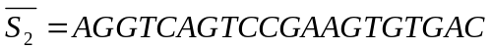
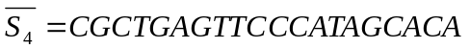
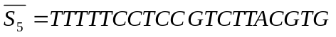
(2) Edge representation:
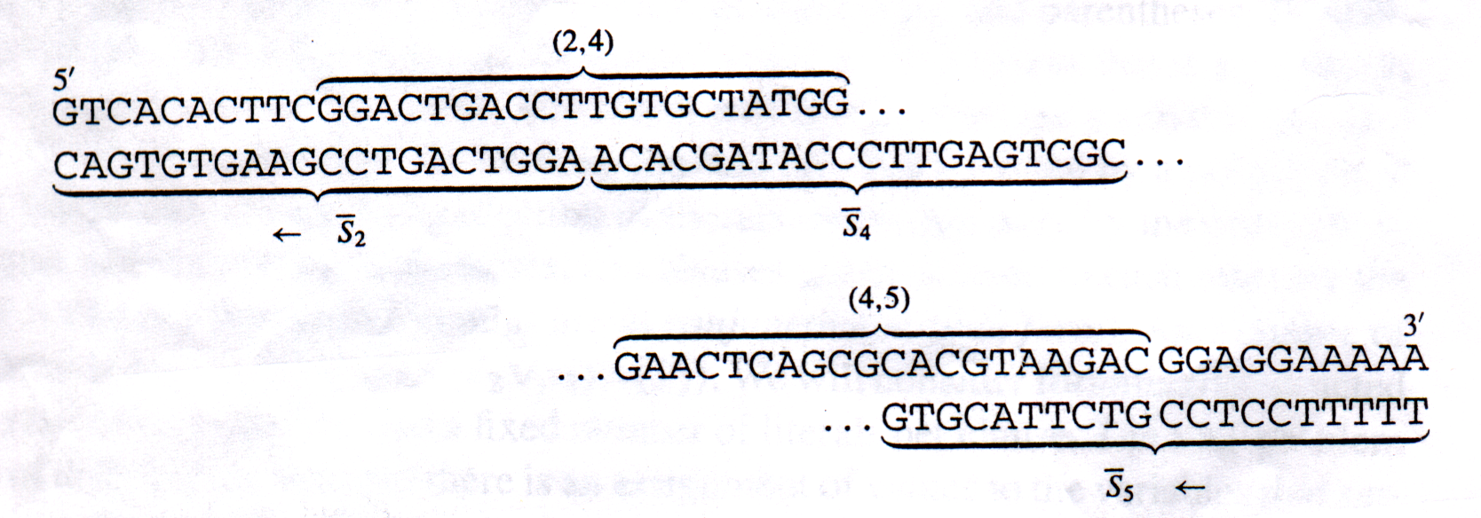
(2,4)=GGACTGACCTTGTGCTATGG
(4,5)=GAACTCAGCGCACGTAAGAC
(3) Path construction:

Step2: Implemented by a polymerase chain reaction using primers S_{S} and 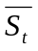.
Step3: Keep those having exactly 20n bases
Step4: Implemented by retaining strands where 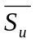
- Satisfiability
In laboratory, we solve SAT with DNA as follows:
- Generate all possible 2^{n} assignments and place them in set S₀.
- From all assignments in set S₀ keep only those that satisfy clause 1, and place them in set S₁.
- From all assignments in set S₁ keep only those that satisfy clause 1, and place them in set S₂.
…
m. From all assignments in set S_{m-1} keep only those that satisfy clause 1, and place them in set S_{m}.

Step1: Construct graph Gn. (to encode the Boolean variable assignments)
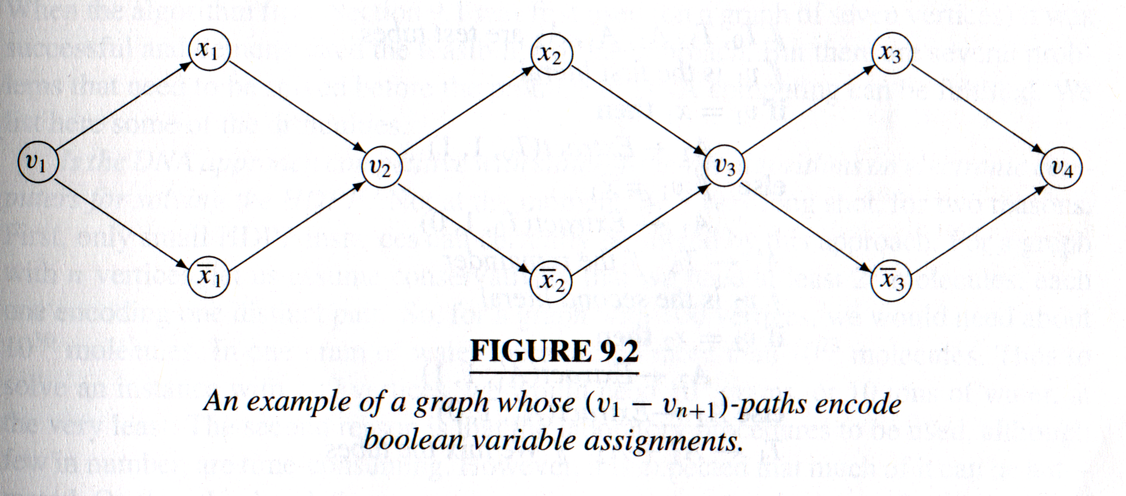
Step2: Detect and Extract
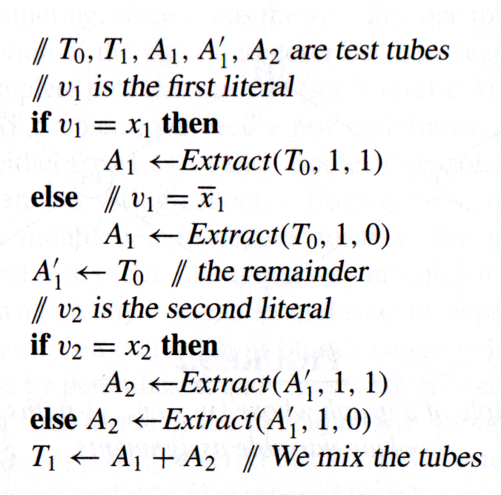
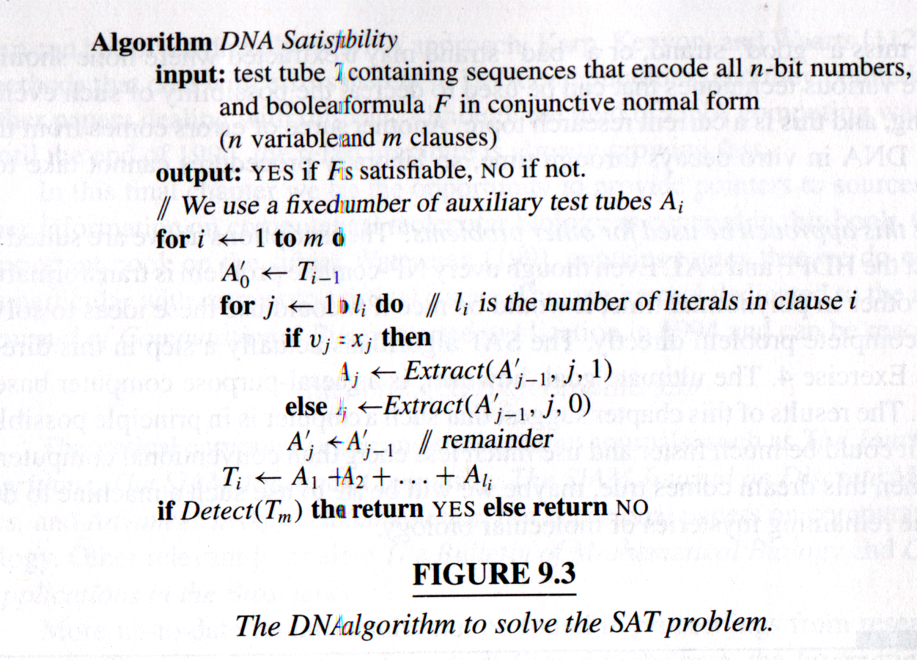
- Problem and Promises
Here we list some difficulties.
  - Is the DNA approach competitive with state-of-the-art algorithms on electronic computers for solving the Hamilton Path Problem?
  - What are the errors that can occur?
  - Can this approach be used for other problems?
Created by: Yi-Ying Chen
Date: Mar. 1, 2001

